**1 Introduction**

The "Online Food Ordering System" has been developed to override the problems

prevailing in the practicing manual system. This software is supported to eliminate and,

in some cases, reduce the hardships faced by this existing system. Moreover, this

system is designed for the particular need of the company to carry out operations in a

smooth and effective manner.

The application is reduced as much as possible to avoid errors while entering the data.

It also provides error message while entering invalid data. No formal knowledge is

needed for the user to use this system. Thus, by this all it proves it is user-friendly.

Online Food Ordering System, as described above, can lead to error free, secure,

reliable and fast management system. It can assist the user to concentrate on their

other activities rather to concentrate on the record keeping. Thus, it will help

organization in better utilization of resources.

Every organization, whether big or small, has challenges to overcome and managing

the information of Category, Food Item, Order, Payment, Confirm Order. Every Online

Food Ordering System has different Food Item needs; therefore, we design exclusive

employee management systems that are adapted to your managerial requirements.

This is designed to assist in strategic planning and will help you ensure that your

organization is equipped with the right level of information and details for your future

goals. Also, for those busy executives who are always on the go, our systems come

with remote access features, which will allow you to manage your workforce anytime, at

all times. These systems will ultimately allow you to better manage resources.

The "Online Food Ordering System" has been developed to override the problems

prevailing in the practicing manual system. This software is supported to eliminate and,

in some cases, reduce the hardships faced by this existing system. Moreover, this

system is designed for the particular need of the company to carry out operations in a

smooth and effective manner.

The application is reduced as much as possible to avoid errors while entering the data.

It also provides error message while entering invalid data. No formal knowledge is

needed for the user to use this system. Thus, by this all it proves it is user-friendly.

Online Food Ordering System, as described above, can lead to error free, secure,

reliable and fast management system. It can assist the user to concentrate on their

other activities rather to concentrate on the record keeping. Thus, it will help

organization in better utilization of resources.

Every organization, whether big or small, has challenges to overcome and managing

the information of Category, Food Item, Order, Payment, Confirm Order. Every Online

Food Ordering System has different Food Item needs; therefore, we design exclusive

employee management systems that are adapted to your managerial requirements.

This is designed to assist in strategic planning and will help you ensure that your

organization is equipped with the right level of information and details for your future

goals. Also, for those busy executives who are always on the go, our systems come

with remote access features, which will allow you to manage your workforce anytime, at

all times. These systems will ultimately allow you to better manage resources.

The "Online Food Ordering System" has been developed to override the problems

prevailing in the practicing manual system. This software is supported to eliminate and,

in some cases, reduce the hardships faced by this existing system. Moreover, this

system is designed for the particular need of the company to carry out operations in a

smooth and effective manner.

The application is reduced as much as possible to avoid errors while entering the data.

It also provides error message while entering invalid data. No formal knowledge is

needed for the user to use this system. Thus, by this all it proves it is user-friendly.

Online Food Ordering System, as described above, can lead to error free, secure,

reliable and fast management system. It can assist the user to concentrate on their

other activities rather to concentrate on the record keeping. Thus, it will help

organization in better utilization of resources.

Every organization, whether big or small, has challenges to overcome and managing

the information of Category, Food Item, Order, Payment, Confirm Order. Every Online

Food Ordering System has different Food Item needs; therefore, we design exclusive

employee management systems that are adapted to your managerial requirements.

This is designed to assist in strategic planning and will help you ensure that your

organization is equipped with the right level of information and details for your future

goals. Also, for those busy executives who are always on the go, our systems come

with remote access features, which will allow you to manage your workforce anytime, at

all times. These systems will ultimately allow you to better manage resources.

The "Online Food Ordering System" has been developed to override the problems

prevailing in the practicing manual system. This software is supported to eliminate and,

in some cases, reduce the hardships faced by this existing system. Moreover, this

system is designed for the particular need of the company to carry out operations in a

smooth and effective manner.

The application is reduced as much as possible to avoid errors while entering the data.

It also provides error message while entering invalid data. No formal knowledge is

needed for the user to use this system. Thus, by this all it proves it is user-friendly.

Online Food Ordering System, as described above, can lead to error free, secure,

reliable and fast management system. It can assist the user to concentrate on their

other activities rather to concentrate on the record keeping. Thus, it will help

organization in better utilization of resources.

Every organization, whether big or small, has challenges to overcome and managing

the information of Category, Food Item, Order, Payment, Confirm Order. Every Online

Food Ordering System has different Food Item needs; therefore, we design exclusive

employee management systems that are adapted to your managerial requirements.

This is designed to assist in strategic planning and will help you ensure that your

organization is equipped with the right level of information and details for your future

goals. Also, for those busy executives who are always on the go, our systems come

with remote access features, which will allow you to manage your workforce anytime, at

all times. These systems will ultimately allow you to better manage resources.

The "Online Food Ordering System" has been developed to override the problem prevailing in the practicing manual system. This software is supported to eliminate and in some cases, reduce the hardships faced by this existing system. Moreover, this system is designed for the particular need of the company to carry out operations in a smooth and effective manner. The application is reduced as much as possible to avoid errors while entering the data. It also provides error message while entering invalid data. No formal knowledge is needed for the user to use this system. Thus, by this all it proves it is user-friendly. Online Food Ordering System, as described above, can lead to error free, secure, reliable and fast management system. It can assist the user to concentrate on their other activities rather to concentrate on the record keeping. Thus, it will help organization in better utilization of resources. Every organization, whether big or small, has challenges to overcome and managing the information of Category, Food Item, Order, Payment, Confirm Order. Every Online Food Ordering System has different Food Item needs; therefore, we design exclusive employee management systems that are adapted to your managerial requirements. This is designed to assist in strategic planning and will help you ensure that your organization is equipped with the right level of information and details for your future goals. These systems will ultimately allow you to better manage resources.

**2 Methodology:**

The simulation first starts with the customer entering his/her credentials (name, ID and password). Once that has been verified, the customer can place an order specifying the quantity of the food required. Now we get a window that displays the order number, customer ID, food name, price and quantity. Once the customer finalizes his/her order, they are redirected to the payment window where the total price is displayed and the customer can select the payment method of their choice and then the customer gets a message of confirmation of order.

The above mentioned simulation flow is with respect to the customer's point of view. Now if you are an admin, you can select the normal login option and enter the admin credentials (email ID and password). Once you enter the admin portal, you get the option of adding food, deleting food or updating food. Any option of choice leads you to the food menu. Once the selected operation is carried out, the end result, i.e , the added food or the updated food.

If admin can changes in the code. Admin having access of the code.

**3 System Design:**

Following are the functional requirements of

• The application must have user registration and login option.

• The application must have registration and sign in option with Facebook API.

• The Application must have a shopping cart for ordering foods.

• The application must have admin registration and login system.

• The application must have password recovery system with email address

• The application must have menu add and edit options for admin.

* The application must have user registration and login option.
* The application must be have shopping cart for food ordering.
* The application must be have admin login system.
* The application must be have password recovery system with email address for user and admin.

• The application must have user registration and login option.

• The application must have registration and sign in option with Facebook API.

• The Application must have a shopping cart for ordering foods.

• The application must have admin registration and login system.

• The application must have password recovery system with email ad

• The application must have menu add and e

**4 Seminar Schedule**:

**5 Implementation Detail:**

We can see that the main view extends and includes three other views which are header, navbar and footer. The header file is the HTML header files, which contains metatags of page. The navbar blade contains the navigation bar of the application. The footer blade contains the footer of the application. The footer blade also contains some JavaScript files needed for the application. The following code snippet shows the header blade. The header blade contains the metatags and CSS links.

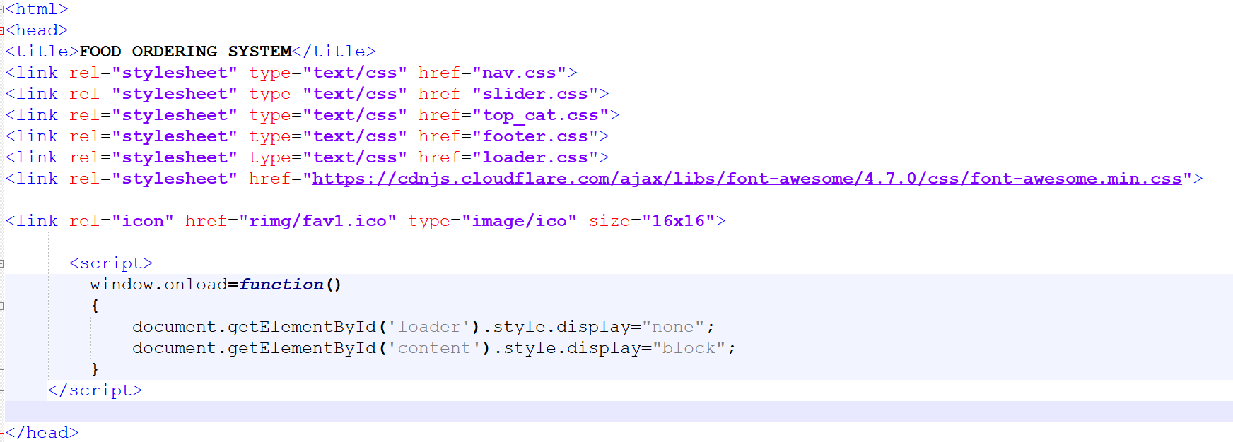

**6 Result (Web Application Snaps):**

**Home page:**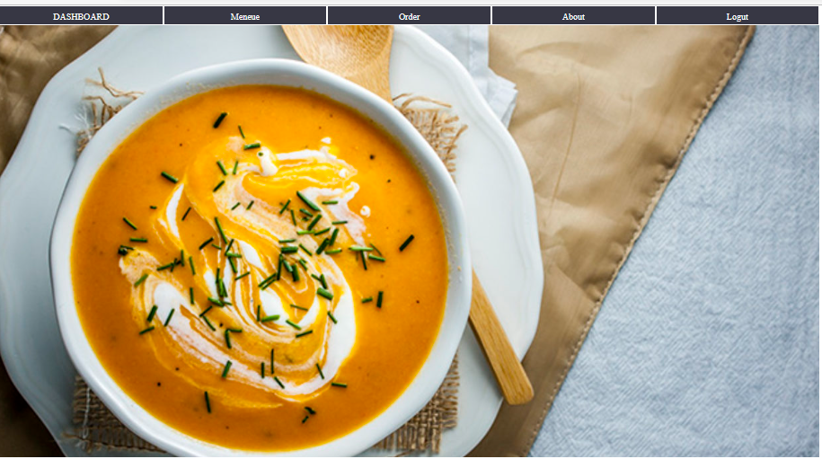

**Menu list:**

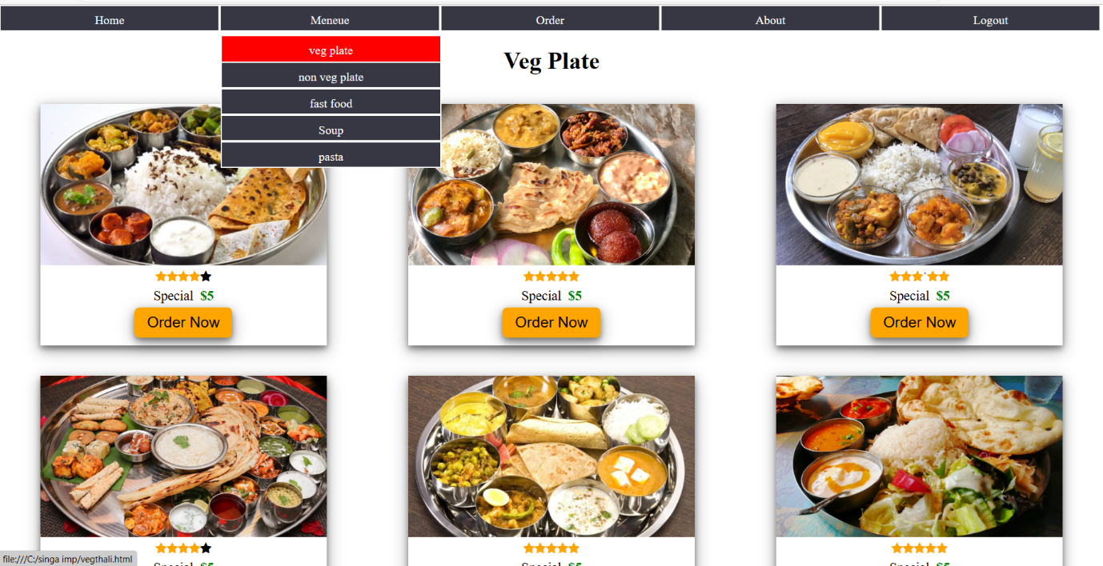

**Order page:**

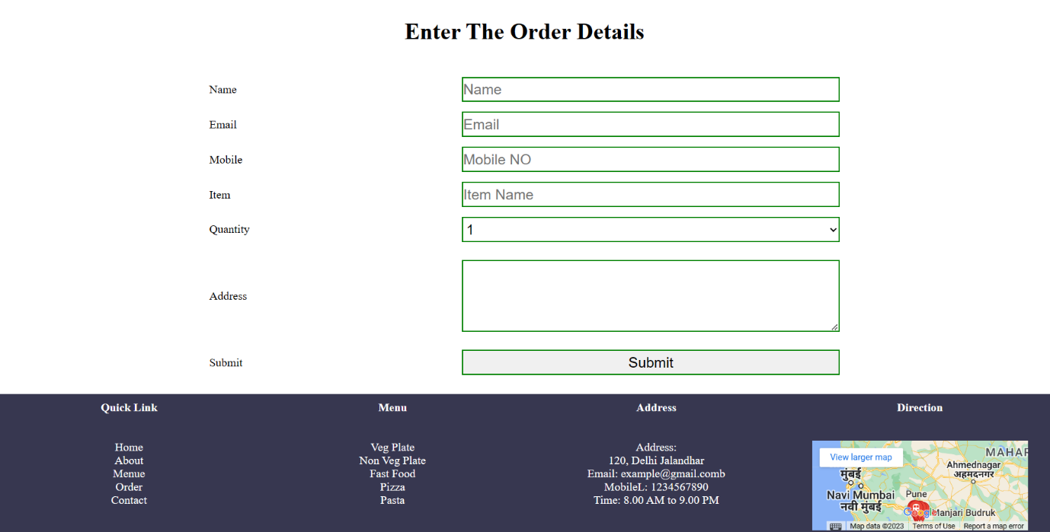

**7 Future Prospect:**

• Allow customers to modify orders: Allow clients to customise their food orders.

• Improve the user interface by include more interactive features for the user. Add information about deals and promotional offers on the home page. Add a week/worth day's of recipes to the home page.

• Payment Options: PayPal, cash, and gift cards are just a few of the options available. Allows you to save payment details for future use.

• Delivery Options: Include a delivery choice.

• Order Process Estimate: Show the customer a graphical order status .

• Order Ready notification: Send an Order Ready notification to the customer.

**8 Conclusion:**